Phase 9: Reporting, Dashboards & Security Review
Admission-Academic Journey Crm
Reports in Salesforce
Reports help visualize data in a meaningful way.
They allow administrators to track performance, analyze student information, and make data-driven decisions.
Salesforce Path:
App Launcher → Reports → New Report
Below are the reports created in my project:
1. Admissions Pipeline Report
Purpose:
To analyze the number of applications received and track them by their current status.
Report Type: Applications
Filters Used:
- Show Me: All Applications
- Date: All Time
- Status = All Values
Columns Used:
- Application Name
- Prospective Student
- Course
- Status
- Application Date
Grouping:
- Grouped by Status
Output:
Shows number of applications in each stage (Submitted, Under Review, Accepted, Rejected).
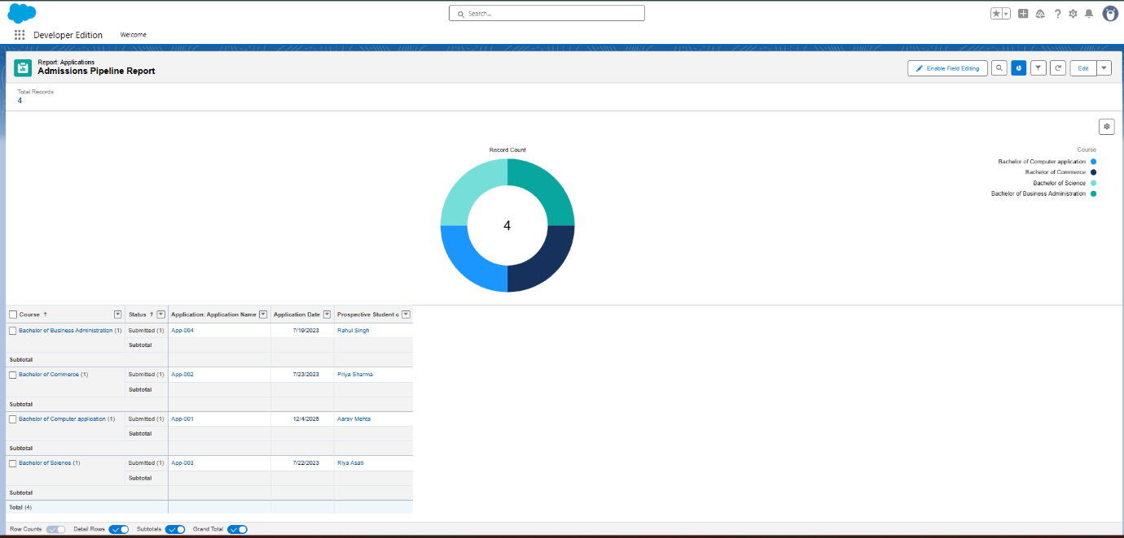
2. Student Conversion Report
Purpose:
To track Prospective Students who got accepted and converted to enrolled students.
Report Type: Prospective Students
Filters Used:
- Show Me: All Prospective Students
- Status = Accepted
- Date: All Time
Columns Used:
- Prospective Student Name
- Email
- Course
- Admission Status
Output:
Displays list and count of accepted students for each course.
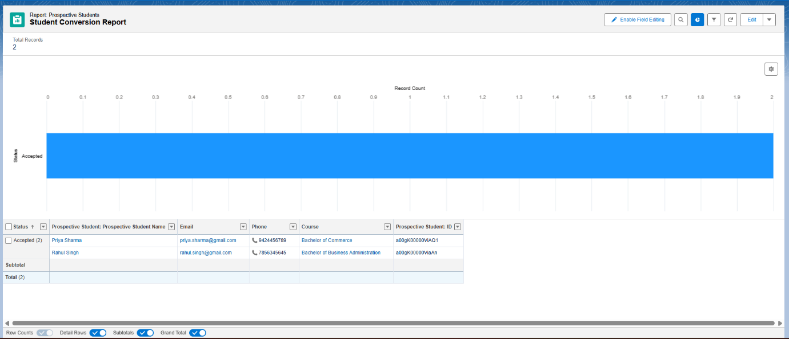
3. Academic Performance Report
Purpose:
To analyze academic performance of students by reviewing their marks, grade, and attendance.
Report Type: Students with Academic Records
Filters Used:
- Show Me: All Students
- Created Date: All Time
Columns Used:
- Student Name
- Course
- Academic Term
- Attendance
- Grade / Marks
Grouping:
- Grouped by Student Name
Output:
Shows course-wise and student-wise academic performance.
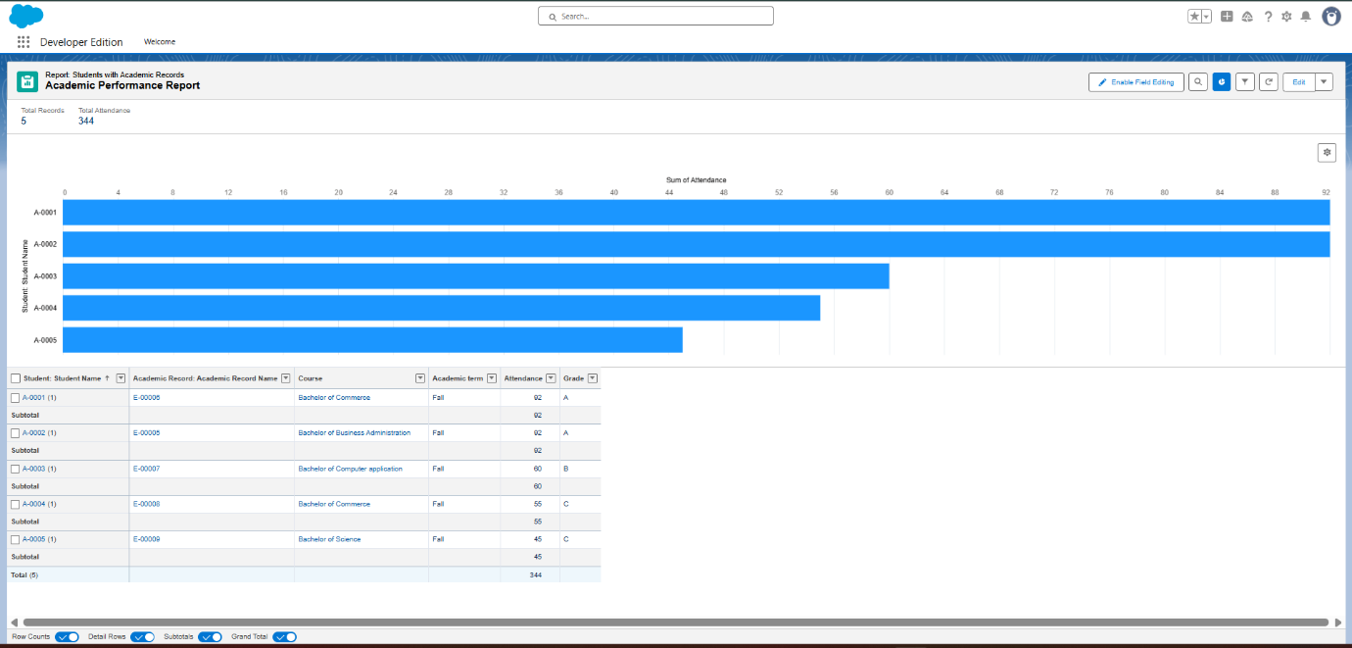
4. Low Attendance Report
Purpose:
To identify students with attendance below 75% and who need support.
Report Type: Students with Academic Records
Filters Used:
- Show Me: All Students
- Attendance < 75
- Created Date: All Time
Columns Used:
- Student Name
- Course
- Attendance
- Academic Term
Output:
Highlights low-performing students based on attendance.
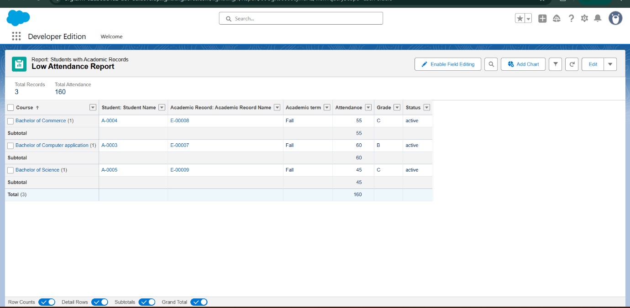
Dashboards in Salesforce
Dashboards provide a visual summary of multiple reports in one place, helping administrators quickly review important metrics.
Salesforce Path:
App Launcher → Dashboards → New Dashboard
A dashboard created for this project is:
Admissions & Academic Dashboard
Dashboard Components:
1. Applications by Status (Donut Chart)
- Based on Admissions Pipeline Report
- Shows number of applications in each stage (Submitted, Under Review, Accepted, Rejected)
2. Applications by Course (Bar Chart)
- Based on Admissions Pipeline Report
- Displays course-wise distribution of applications
3. Academic Performance Overview (Bar Chart)
- Based on Academic Performance Report
- Shows average marks or grade distribution
4. Low Attendance Students (Table)
- Based on Low Attendance Report
- Lists students whose attendance is below 75%
5. Total Accepted Students (Metric)
- Based on Conversion Report
- Shows total number of enrolled/accepted students
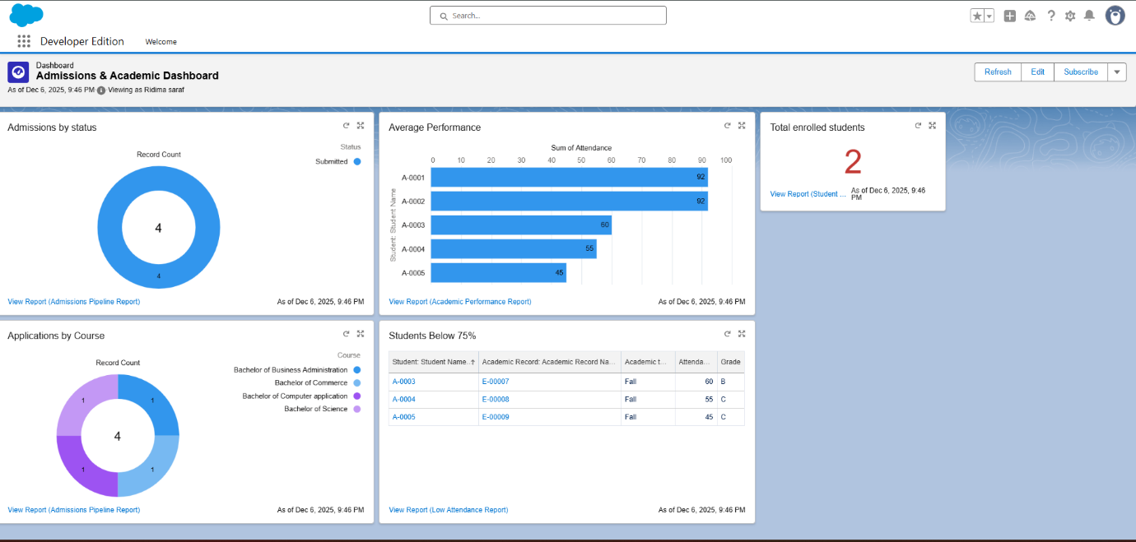
Security Review in Salesforce
Security ensures data protection and proper access to records.
1. Field Level Security (FLS)
Sensitive fields like personal details, marks, and comments are restricted to specific profiles.
Salesforce Path:
Setup → Object Manager → Academic Record / Prospective Student → Fields & Relationships → Field Level Security

2. Sharing Settings
OWD and sharing rules ensure that only authorized users can view or edit student academic information.
Salesforce Path:
Setup → Sharing Settings

3. Audit Trail
Used to track configuration changes for better transparency and governance.
Salesforce Path:
Setup → View Setup Audit Trail
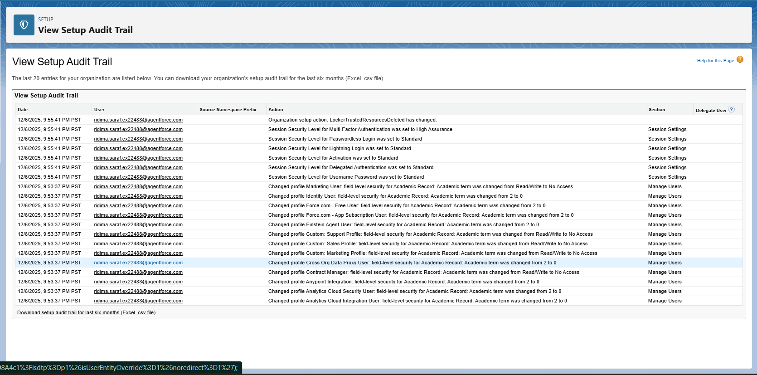
4. Login Access Policies
Ensures secure access to Salesforce org and prevents unauthorized usage.
Salesforce Path:
Setup → Login Access Policies.
Overall Summary
Phase 9 provides a complete analytical view of the student admission and academic journey using Salesforce Reports and Dashboards, helping administrators make informed decisions efficiently.

